Construction Instructions

Materials
Material | Quantity
2’ PVC pipe | 8
4’ PVC pipe | 4
T-adapter | 8
Zip Ties | 8
2’ x 3.5’ Plywood | 1

Tools
- Drill
- Saw

Step 1: Cut PVC

Instructions
Cut PVC into the following lengths:
Material | Quantity
2’ PVC pipe | 8
4’ PVC pipe | 4

Diagram/Picture

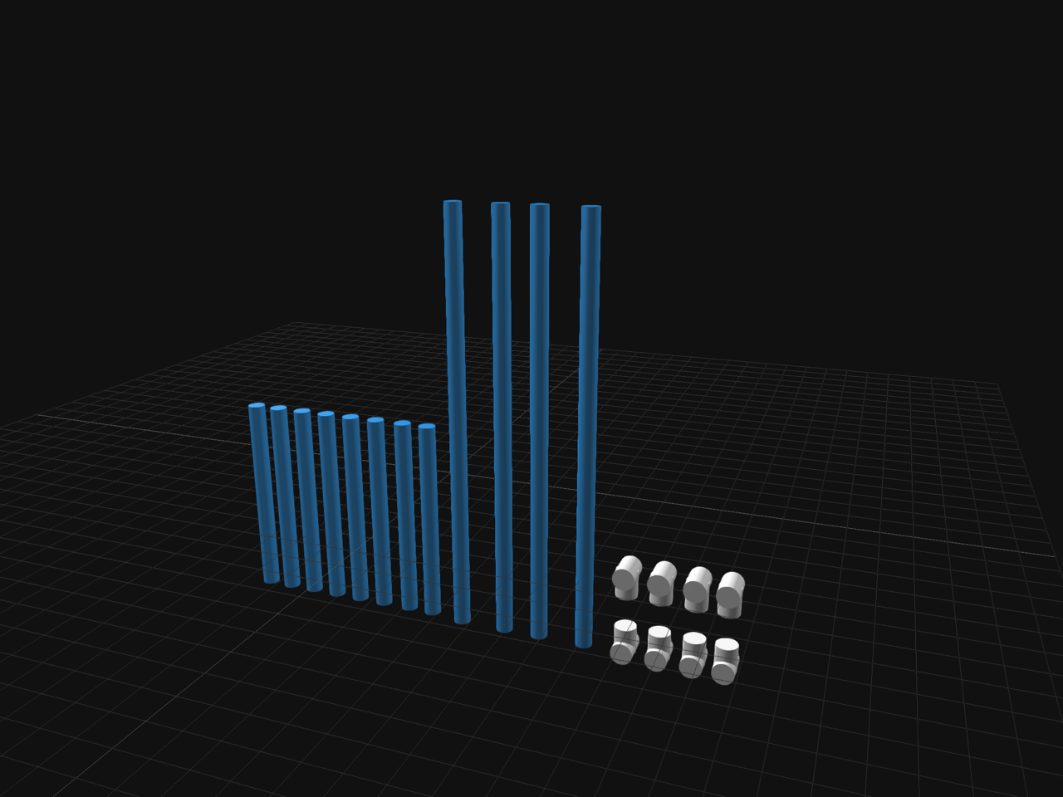

Materials
32’ of PVC

Tools
Saw

